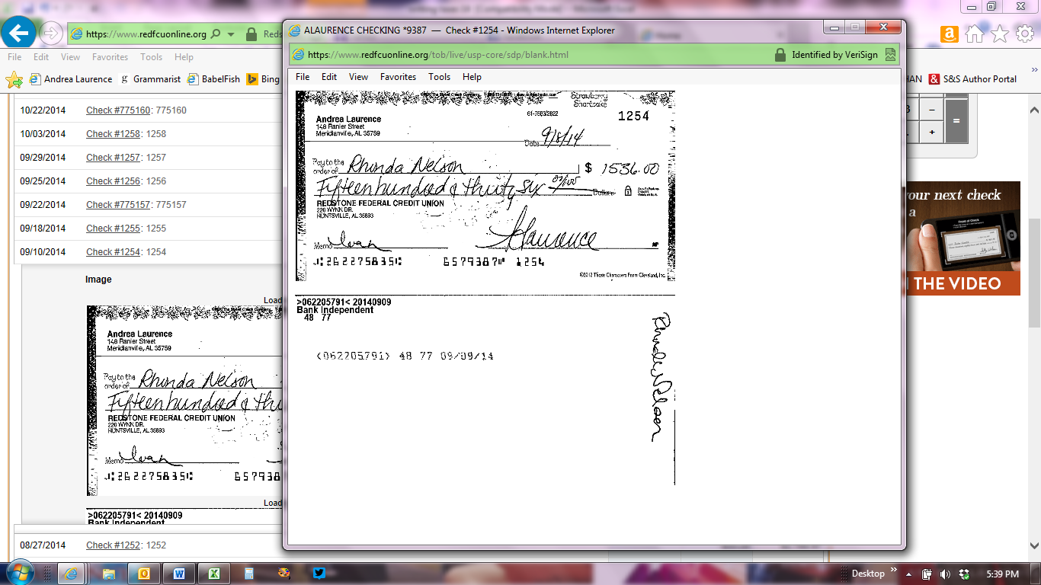

Check 1235 - $2000, 8/30/14 to Rhonda Nelson

